*PERSONAL PROFILE*

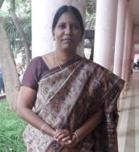

**Name: MSK KRISHNA JYOTHI**

**Designation:Lecturer in History**

College Address:SRR&CVRGovtDegreeCollege(A),Vijayawada

CellNo: 9110728070

Mail Id:mskkrishnajyothi@gmail.com

**Educational Qualifications**

|  |  |  |  |  |
| --- | --- | --- | --- | --- |
| **S.NO** | **COURSE** | **BOARD/**  **UNIVERSITY** | **YEAROF**  **PASS** | **PERCENTAGE** |
| 1 | S.S.C. | BOARDOF  SECONDARY  EDUCATION | 1990 | 61% |
| 2. | INTERMEDIATE | BOARDOF  INTERMEDIATE  EDUCATION | 1990-1992 | 61% |
| 3 | B.Sc.  MBF(Microbiology  Biochemistry  Food&Nutrition) | Andhra  University | 1993-1996 | 76% |
| 4 | M.Ed.  Biochemistry | KSOU  University | 2002-2004 | 64% |
| 5 | MA History | BRAOU  University | 2012 | Distinction |

**Professional Experience:**

1. Worked as a School assistant in Zilla Praja Parishad Schools in SPSR Nellore for 17 years

2. Joined as a Lecturer in History in SRR & CVR Government Degree College on 07-06-2018

Orientation Course:

Completed with A+ grade from June 26th to July 24th, 2020 with Teaching Learning Centre, Ramanujam College, University of Delhi (online)

Refresher Course:

Completed with A+ grade from 11th to 26th of March 2021 with Teaching Learning Centre, Ramanujam College, University of Delhi (online)

Workshops/FDPs attended:

1. History Matters: The past, present and future-social, cultural, political & economic foundations from 20th July to 24th July 2020 conducted by Commissioner of Collegiate Education.
2. 5 day FDP in LMS Video & Pedagogy from 3rd August, 2020 to 7th August 2020 conducted by Commissioner of Collegiate Education.
3. 3 Day FDP on Podcast held from 12th to 14th August 2021 organised by APSHE, Government of AP in association with Commissionerate of collegiate Education, A.P.

International:

1. Domestic Violence an International oneday workshop held on 13th December 2018 at Sri Durga Malleswara Siddhartha Mahila Kalashala, Vijayawada.
2. Kamala Nehru College University of Delhi conducted two days International webinar titled, “Dil-O-Dilli” by Department of History in Association with INTACH on 11th and 12th June, 2020.

National:

1. Viswanatha Sahitya Samalochana National seminar at SRR & CVR Degree College 7th &8th September 2018.

2. Varanasivari Geyakavitha Vaibhavam oneday workshop at SRR & CVR Degree College on 5th December 2018.

3. One week Workshop on Teaching and Learning for Sustainability from 14-11-2-19 to 20-11-2019.

4. One day National Webinar on “Impact of Covid-19 on Indian Economy: Surval strategies for Banking, Education, Pharma and Retail Secotrs” on 19-05-2020 conducted by the department of Economics, SRR&CVR Governemnt Degree College.

5. Two days National seminar on “Impact of covid-19 on the Migrant labour in India” on 26th & 27th February, 2021 at Ideal College of Arts and Science, Kakinada.

Few Achievements and Awards:

1. Stood second in Woman General Category in DL recruitment by APPSC

2. Received Paryavaran Mitra best Teacher from honourable ex-President Sri APJ Abdul Kalam in the year 2010.

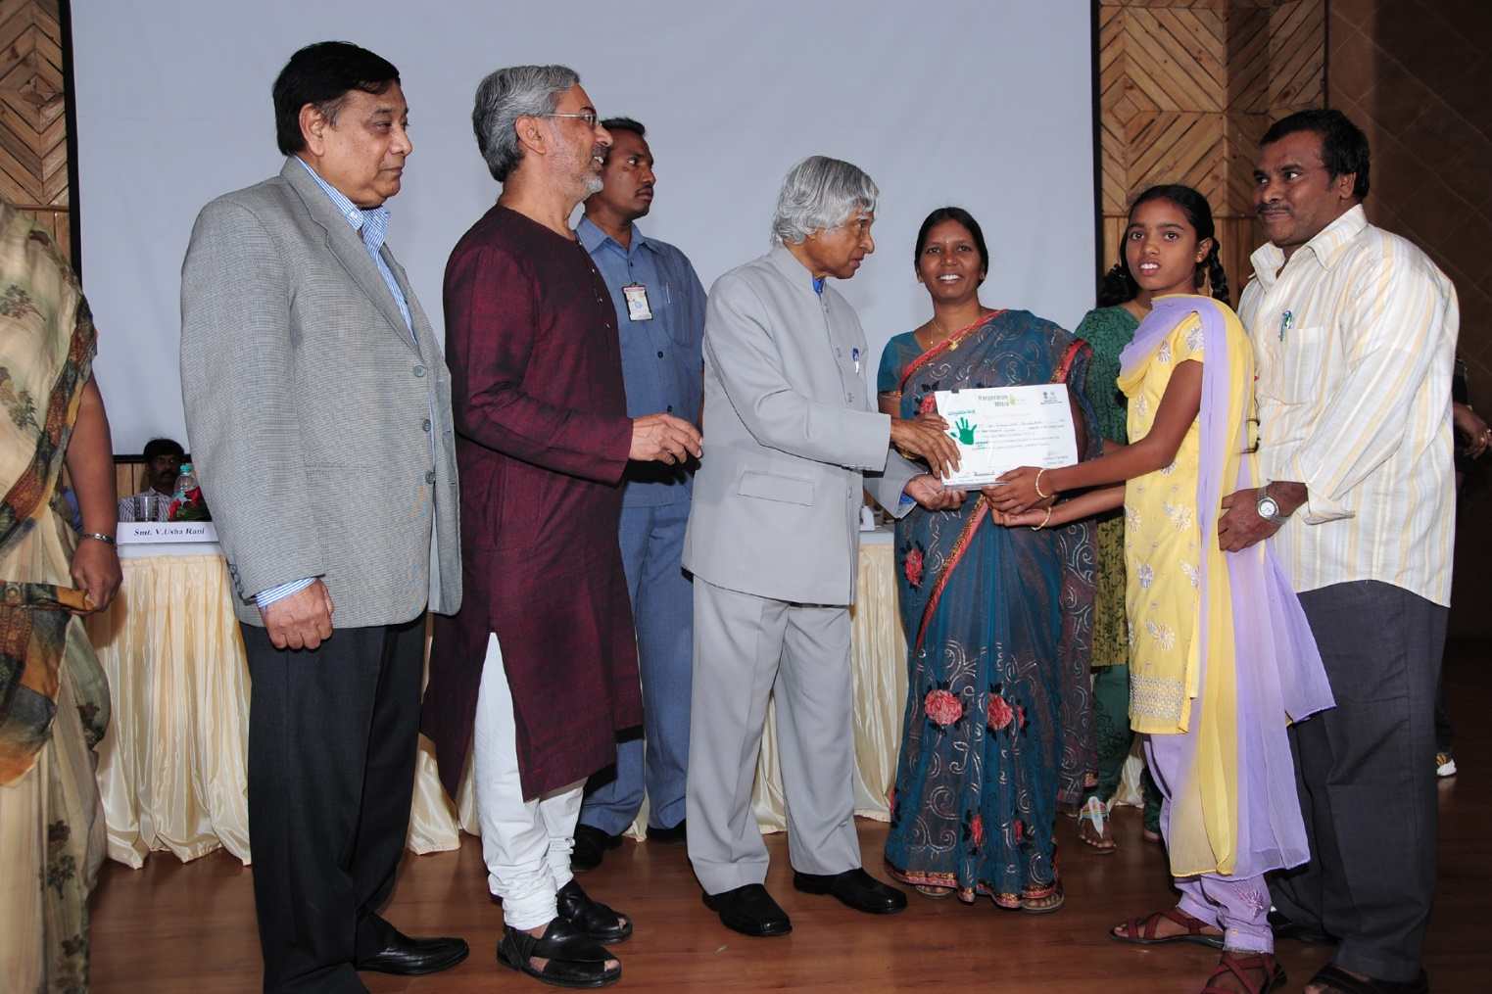

Receiving Paryavarana Mitra Award from Dr.APJ Abdul Kalam

1. Received Best Poetess National Award on 2-11-2015 from Dr.C.Narayana Reddy the most famous Telugu Poet. The poetry competition was held by Sri Kiran Cultural association, Hyderabad.

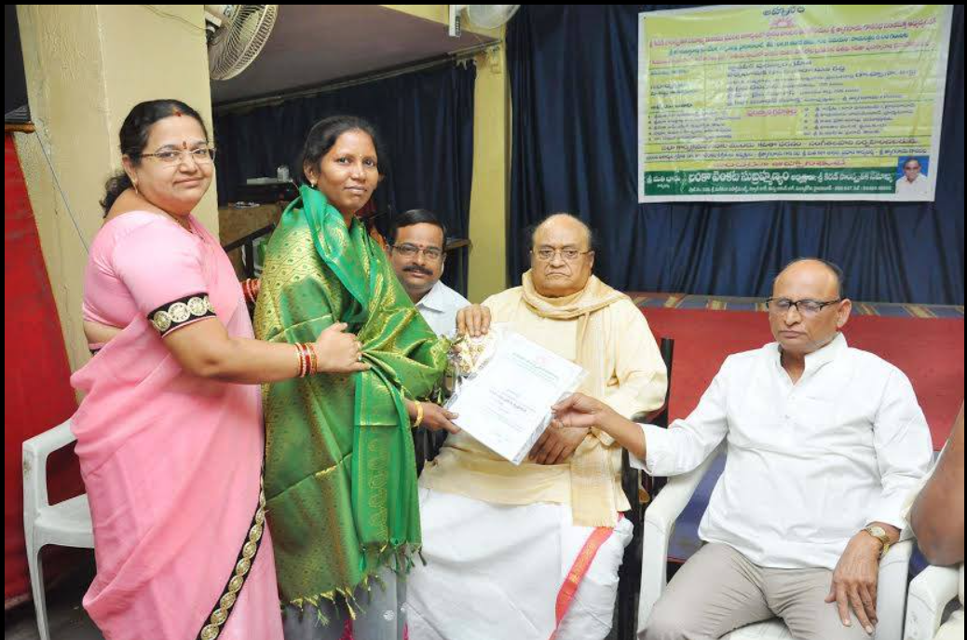

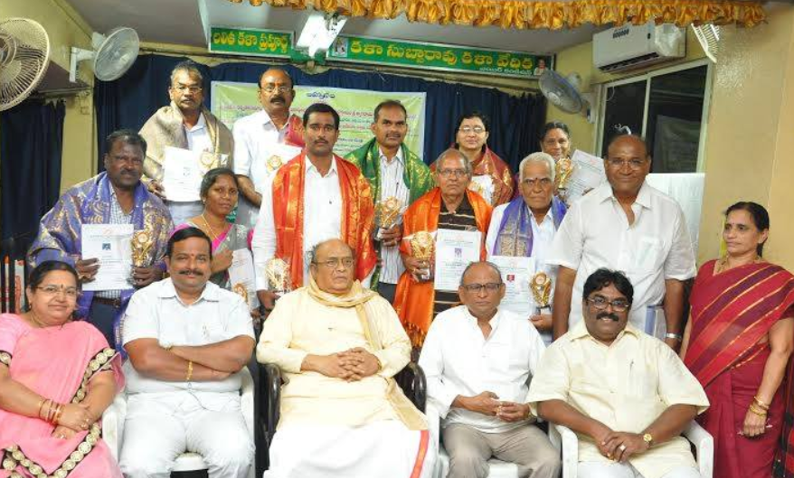

1. Received Prestigious Raavishastri National Award from the able hands of Goreti Venkanna, Sahitya Academy Award Winner. Raavishatri was a great Telugu story writer famous for his outstanding pun and social awareness.

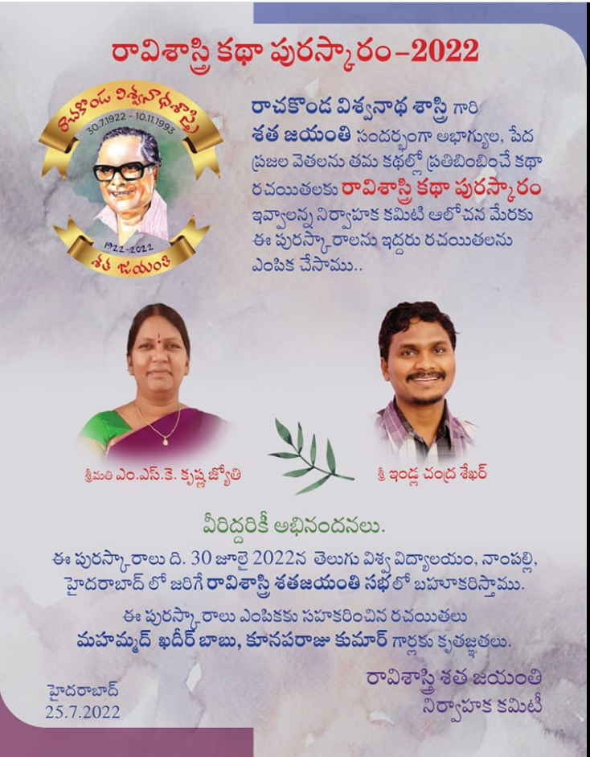

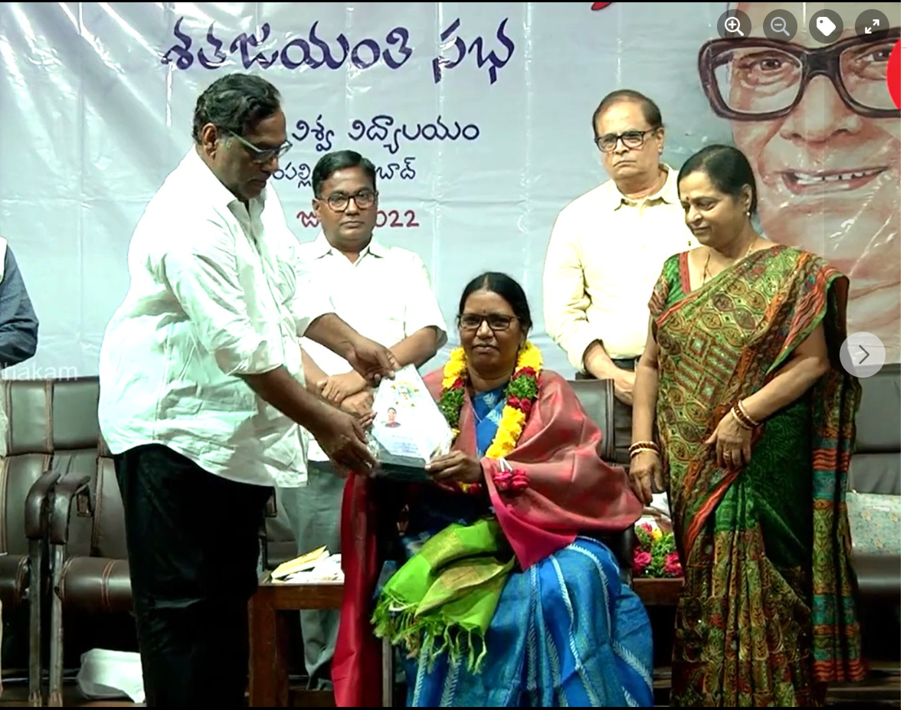

Few important Publications:

1. Telugu Teeseste Nashtame, Telugu Velugu, September 2020, ISSN 2582-1539
2. Impact of Covid-19 on the Migrant Labour in Health Hygiene and Hazards of Viral Spread, 26th, 27th Feb, 2021, ISBN: 978-81-94706144.
3. Municipal Towns of West Godavari District and History of their Formation; 2022 IJRAR December 2022, Volume 9, Issue 4
4. Antique remains of Literacy in Ellore; February 2023 | IJIRT | Volume 9 Issue 9 | ISSN: 2349-6002

Few Books:

1. A book titled, Kottapandaga was published in 2019. It was a compilation of short stories published in different magazines for four years. The book got great applause.

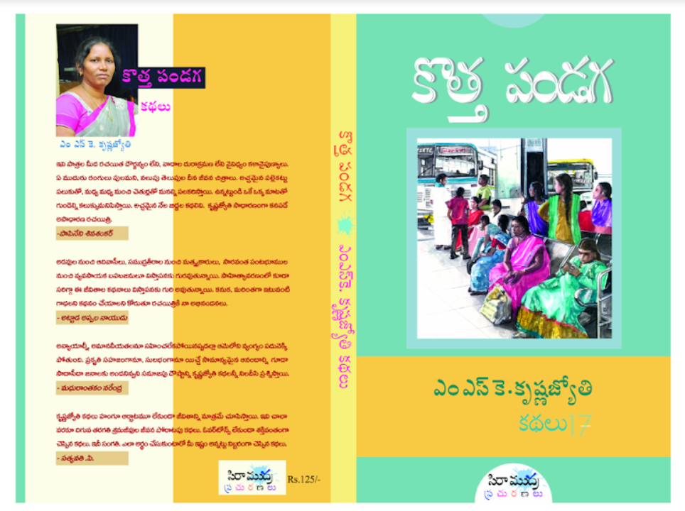

1. Ocean Boy, Short story published in The Best Stories of Our Times, Edited by Volga, Translated by Alladi Uma and M Sridhar, from the prestigious Harper Perennial publications, 2022, ISBN: 978-93-5489-343-8.

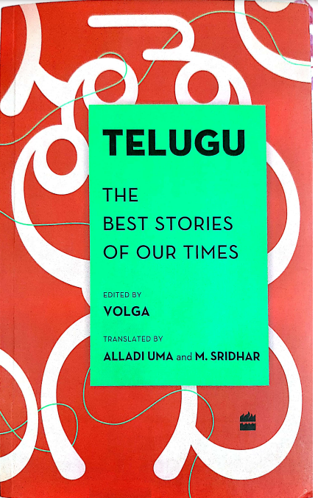 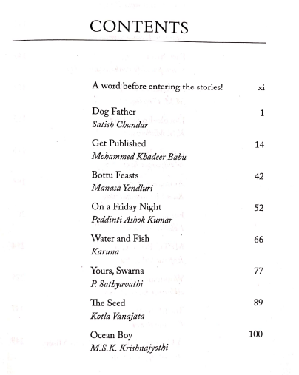

1. Telugu Logillalo Pashu Pakshyadula Kathalu, 2022 November

